ALGORITHM FOR RELATION BETWEEN DRONE FLYING HEIGHT AND PIXEL SIZE

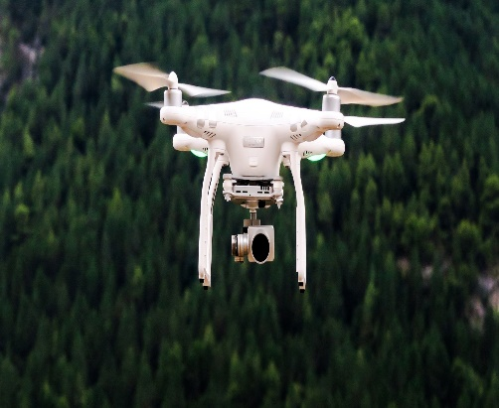

SAMPLE DRONE

To find the relation between drone height and pixel size, we can use trigonometric relation.



Let be θ = 750

h(height)

x

2x

(Total distance)

ALGORITHM:

1. Let us define the height the drone be ‘h’ and it total distance (covering area) be ‘2x’ and the angle at which the drone flying be say 750.
2. In the drone view figure, consider a right angle triangle and it’s angle be half of original drone angle 75/2 and its distance ‘x’ be half of total covering distance.
3. In order find its pixel size, we have to define how many pixels you want in x-direction and also in y-direction.
4. We can say for e.g. 4000 pixels for x-direction and 3000 pixels for y-direction. As we know image is an array of pixels.
5. With the help of trigonometric relation tan θ = opp/adj and known height say drone flying at height of ’30’m above the ground level, we can find the distance ‘x’.
6. Equation, tan(750/2) = x/h substituting h=30, tan(37.50) = x/30.
7. Rewriting the above equation, we can get x = 30\*tan (37.50), solving this we get x = 23m.
8. Therefore, Total distance it covered = 2x, substituting x = 23, We get Total distance it covered is equal to 46m.
9. Finally, We can find the pixel size by pixel size = total distance / pixel in x-direction.
10. Pixel size = 46 / 4000, solving this we can get Pixel size = 0.0115m ( 1.15 cm).